|  |  |  |  |  |  |
| --- | --- | --- | --- | --- | --- |
| Date | 6-Dec-22 | | | Tester Name | Mohammad Yusuf |
| Environment | Penfax - Test | | | Login used |  |
| Operating System | Select OS | Version: | Update: | | |
| Software Used | Select Software | Version: | Update: | | |
| Select Software | Version: | Update: | | |
| Release version |  | | | | |
| Title | M17 Contributions & DCT | | | | |
| Test Type | Regression | | | | |
| Test Scenario | M17.08 Creating a Leave of Absence File | | | | |
|  |  | | | | |
| Expected Results | Leave should be applied to Employee Profile. | | | | |
| Pass/Fail | Pass | | | JIRA# | N/A |

Describe your steps with screenshots:

1. Bring up an active MEPP member who is going on LOA.

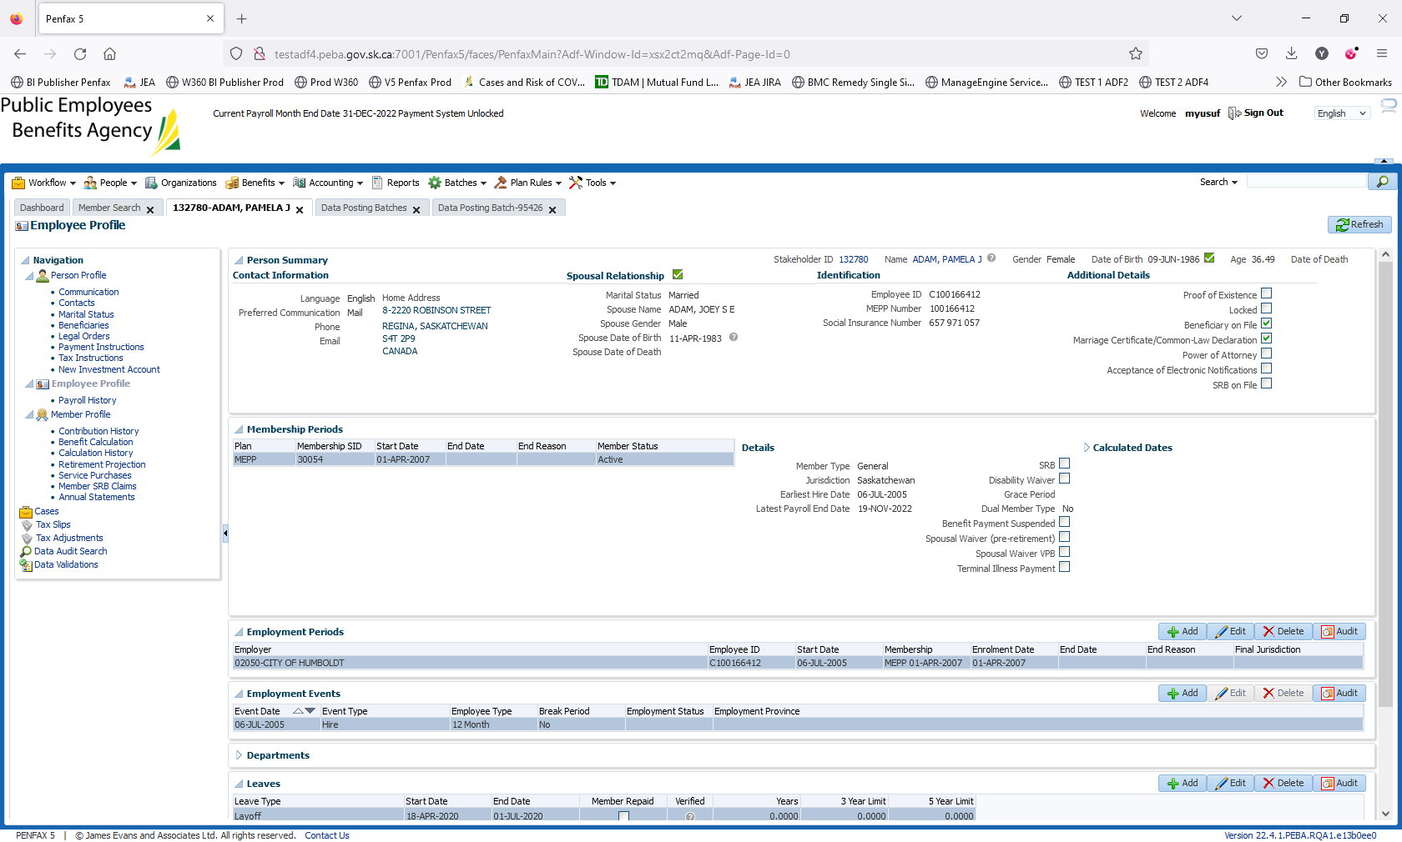

1. Log into MEPP DCT and select the Employer from the dropdown. Click on Create New File.

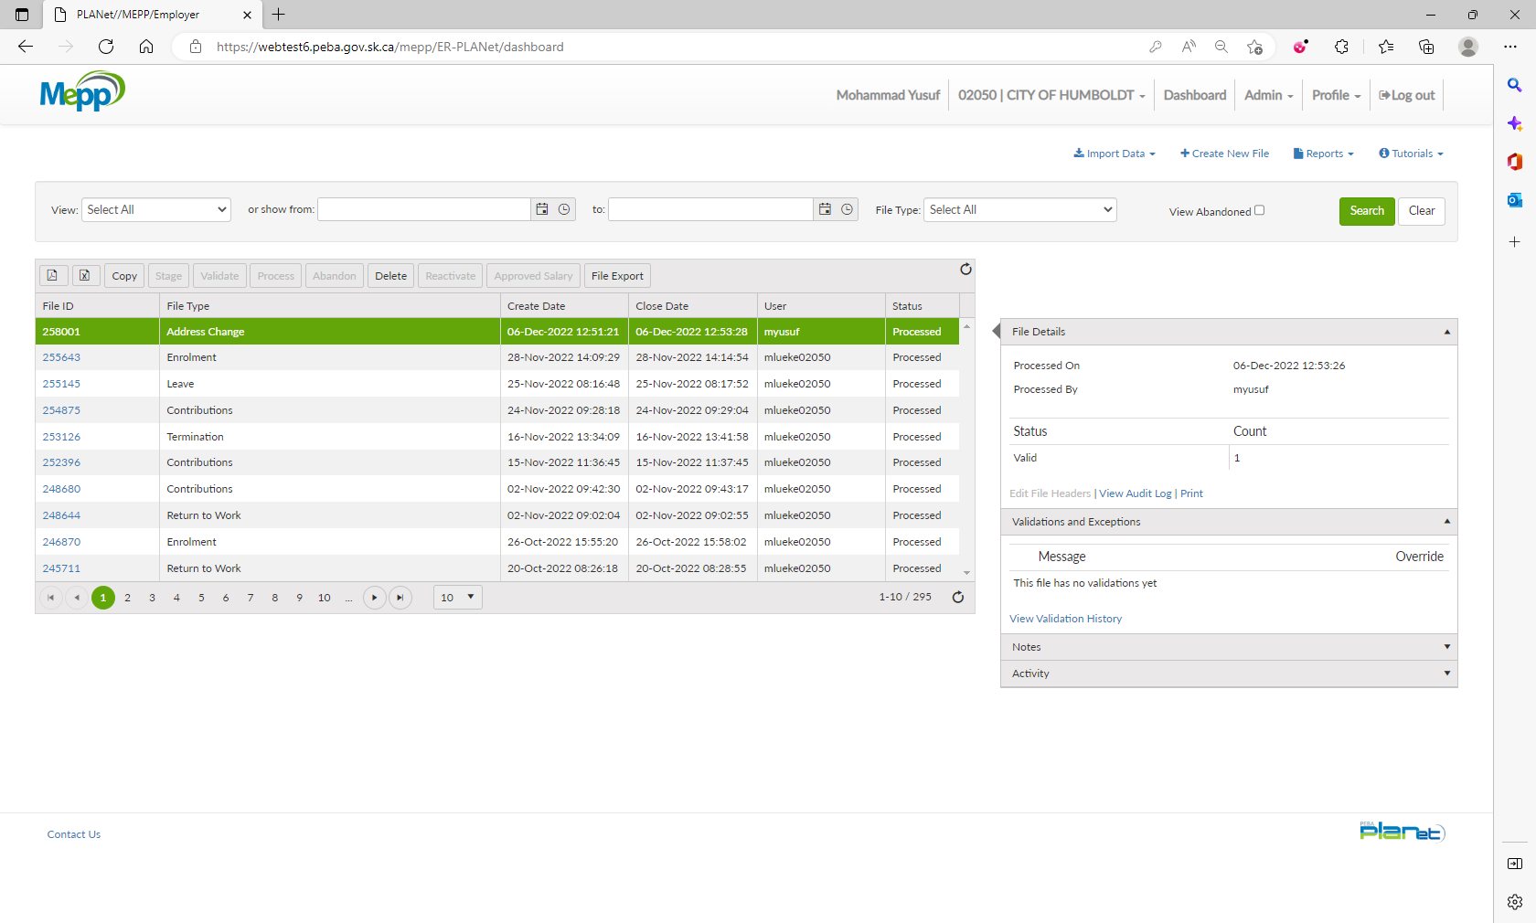

1. Select Leave from the dropdown and click Create.

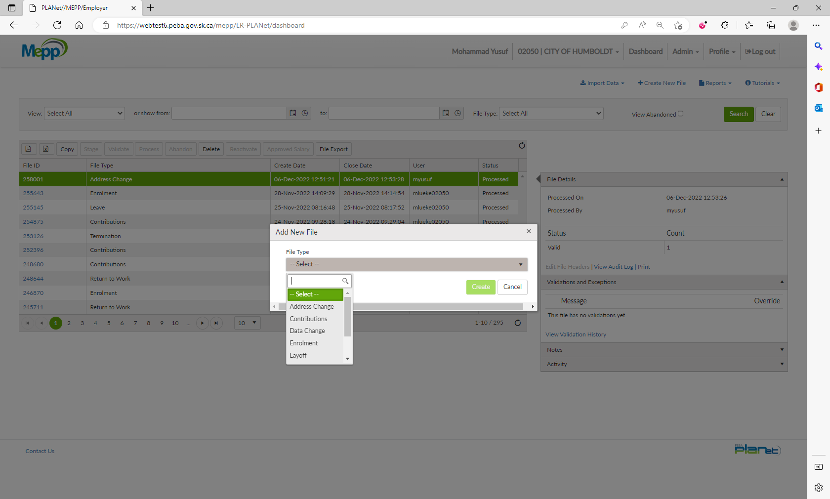

1. Click on File ID to add the transactions.

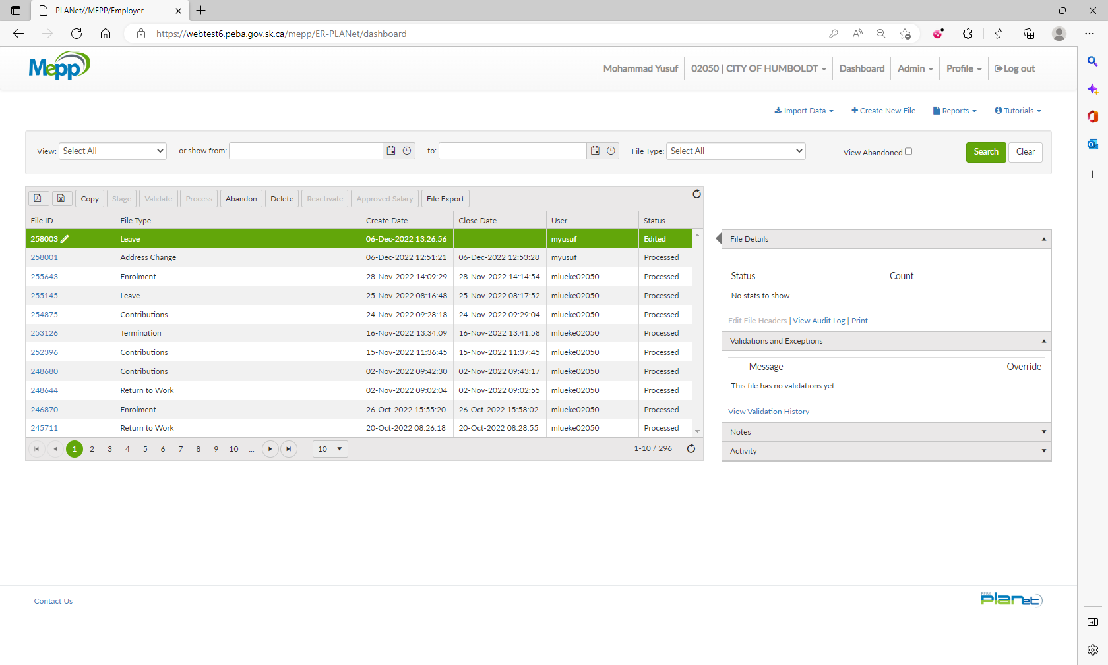

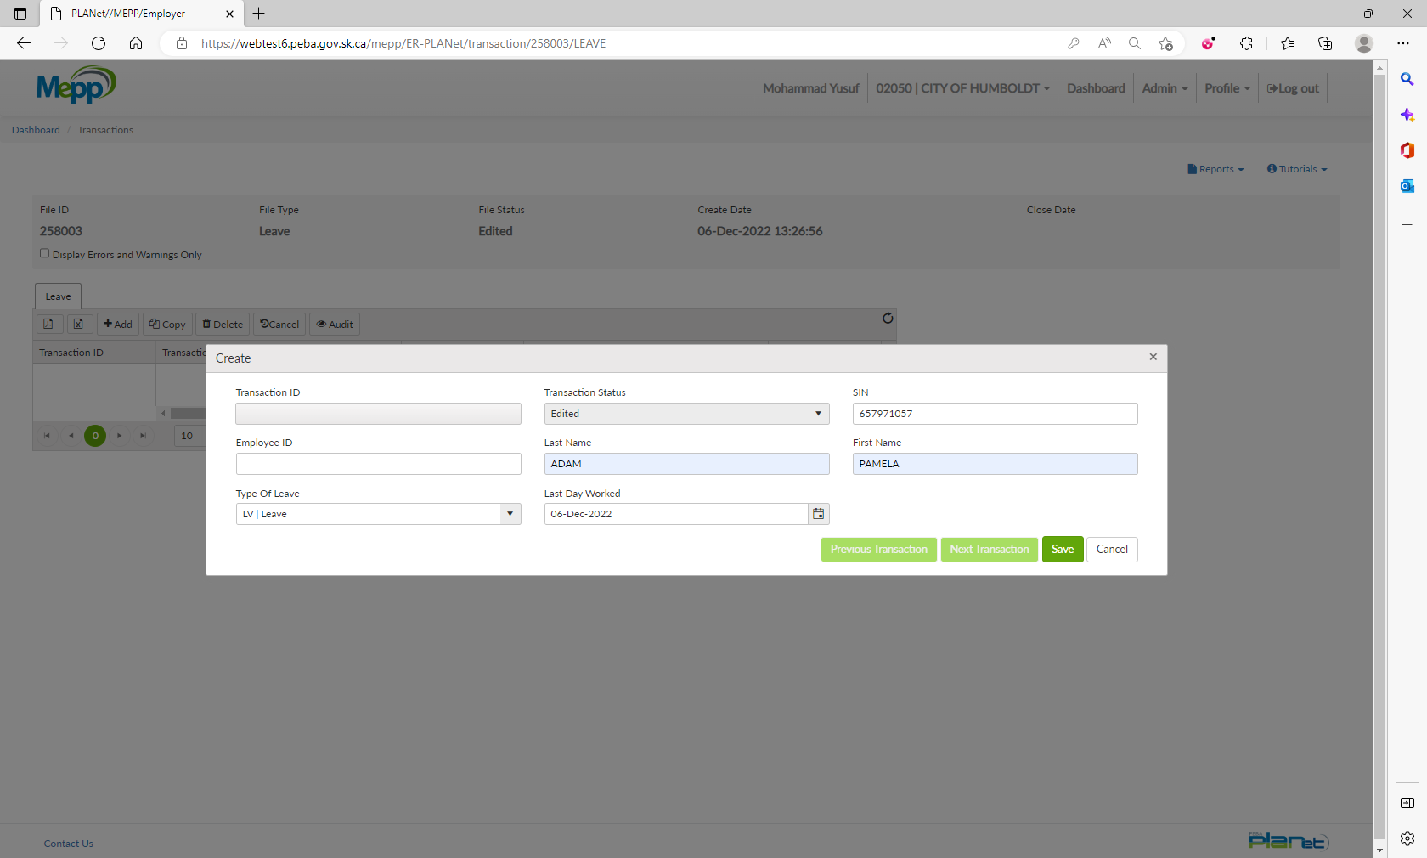

1. Input required details and click Save.
2. Under File Details, click on Validate and then Process.

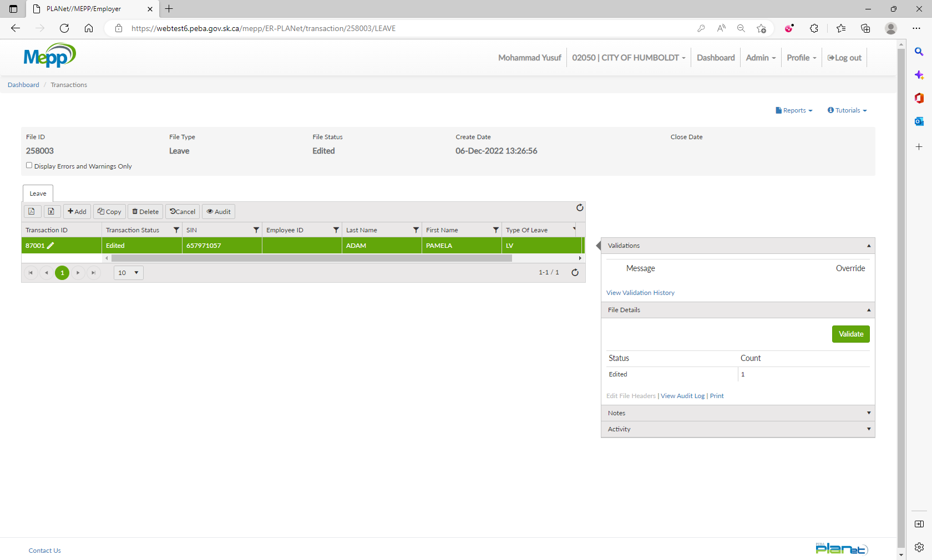

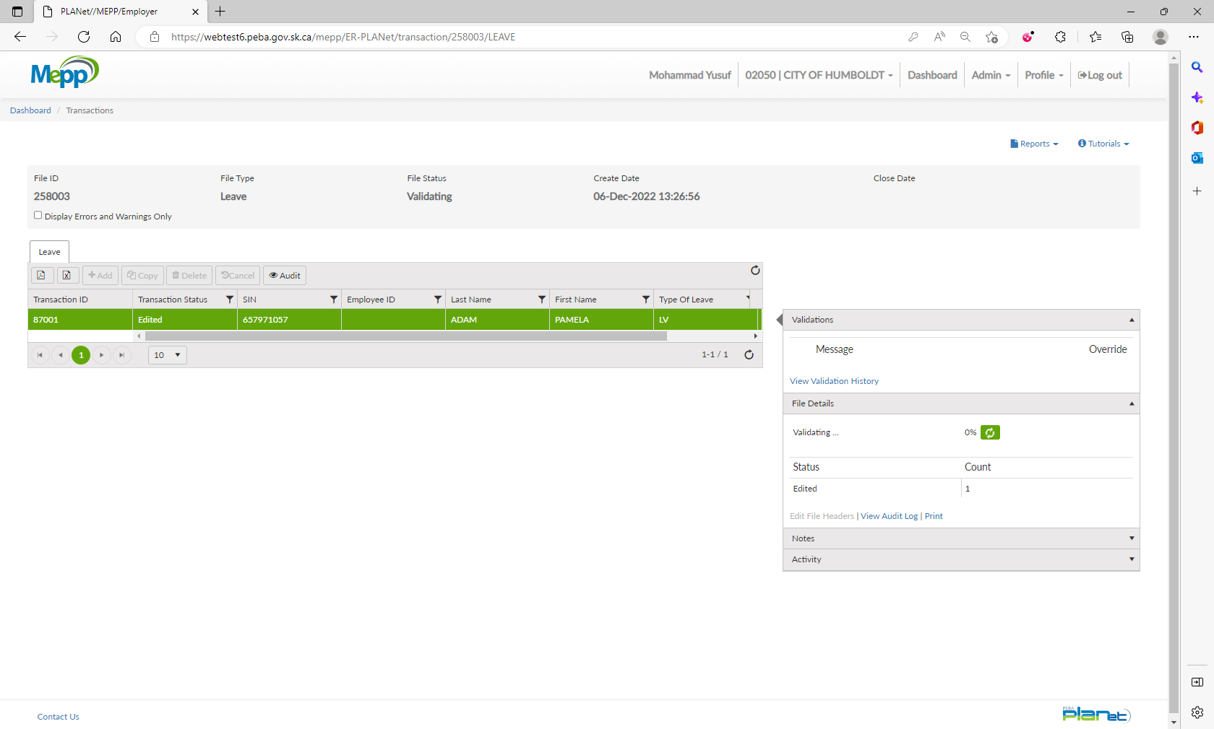

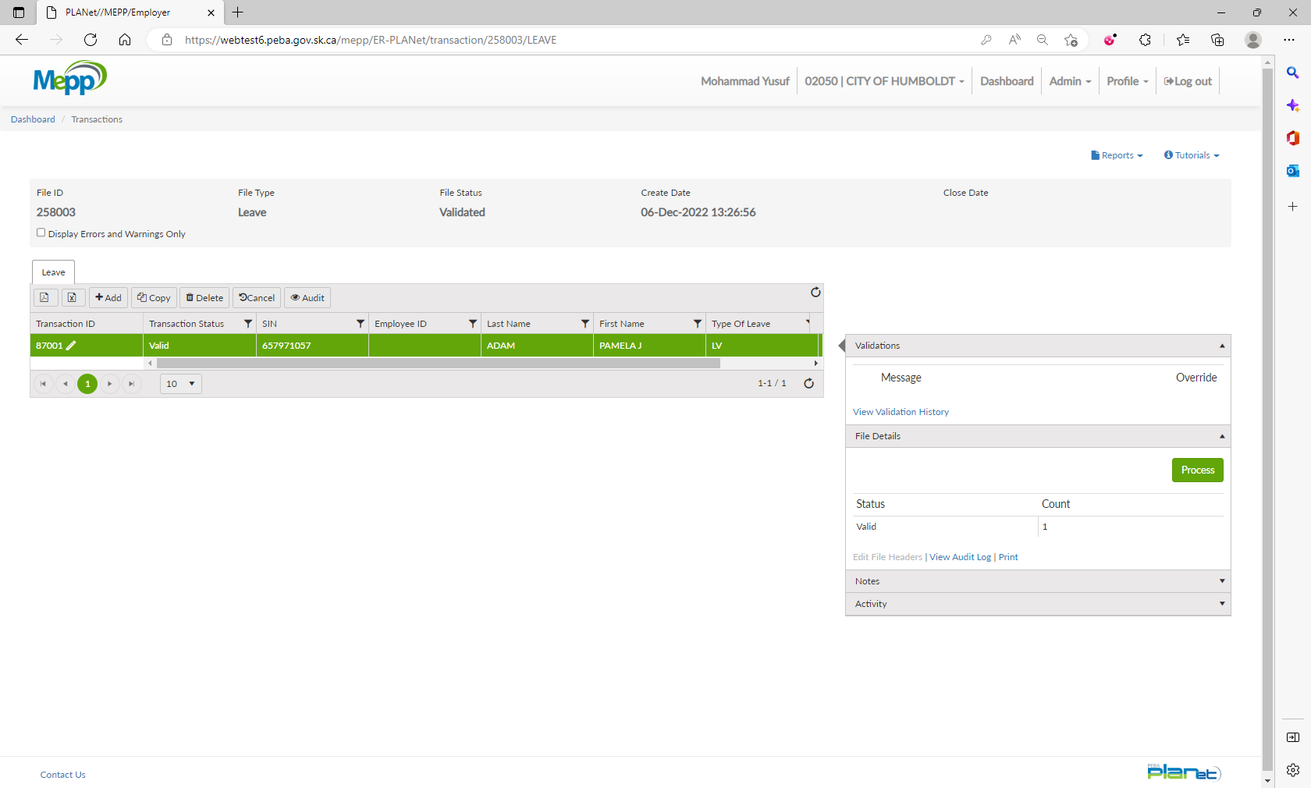

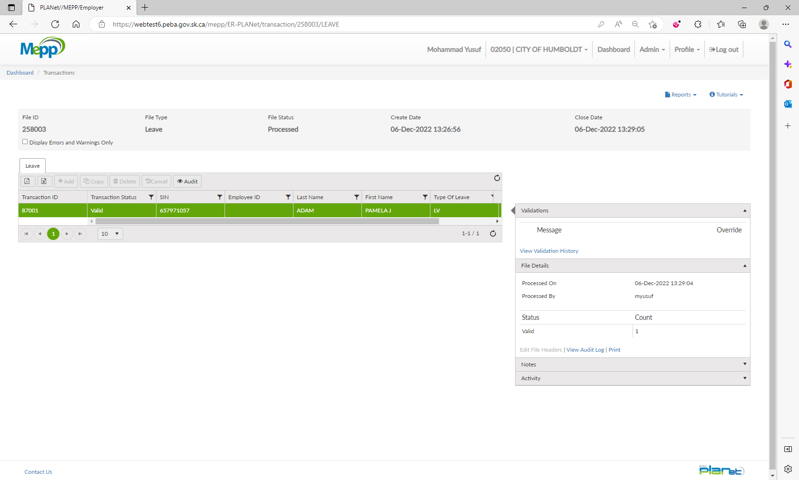

1. Go to Penfax -> Data Posting Batch -> Search by Batch Type and Employer.

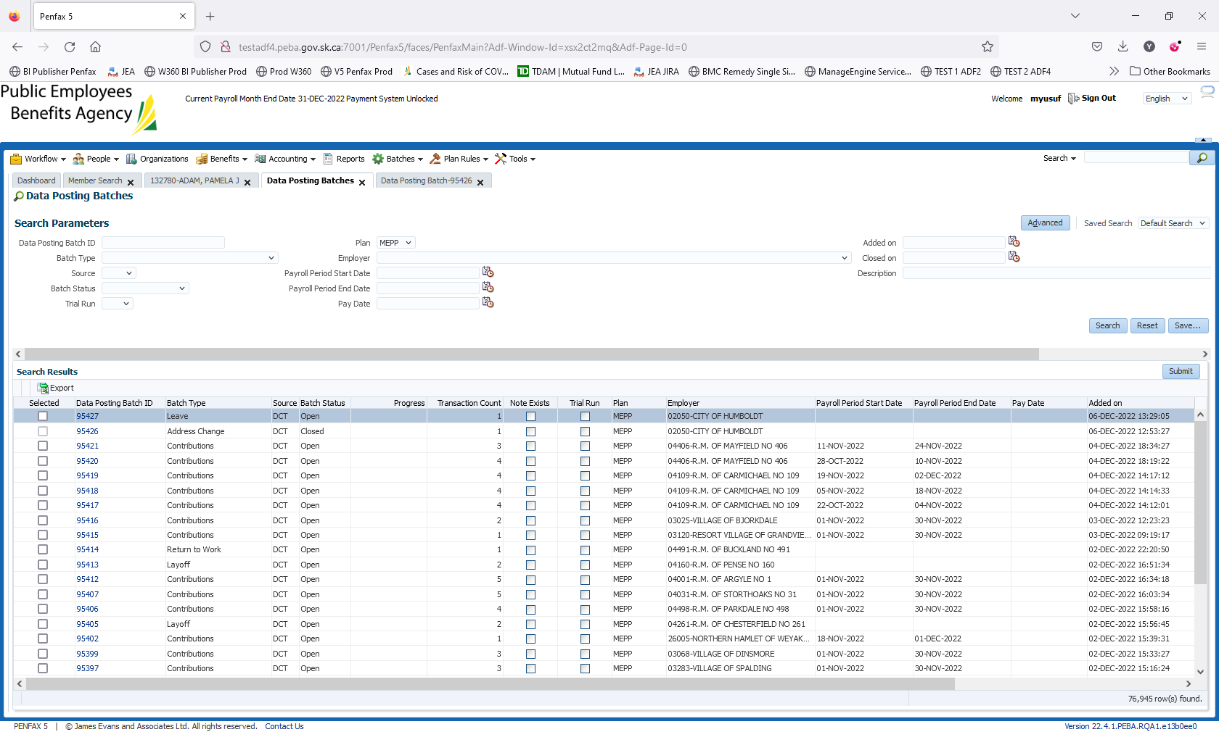

1. Open a batch you just processed through DCT. Go to Pending tab.

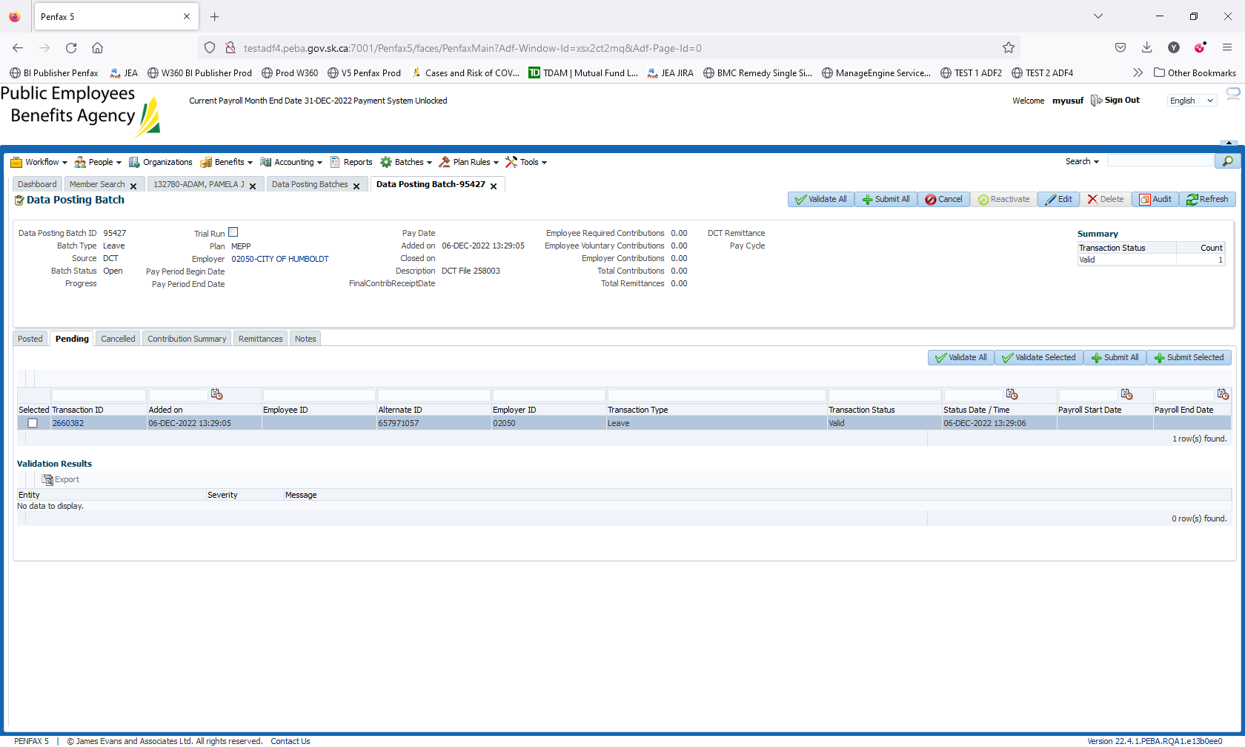

1. Click on Validate All.

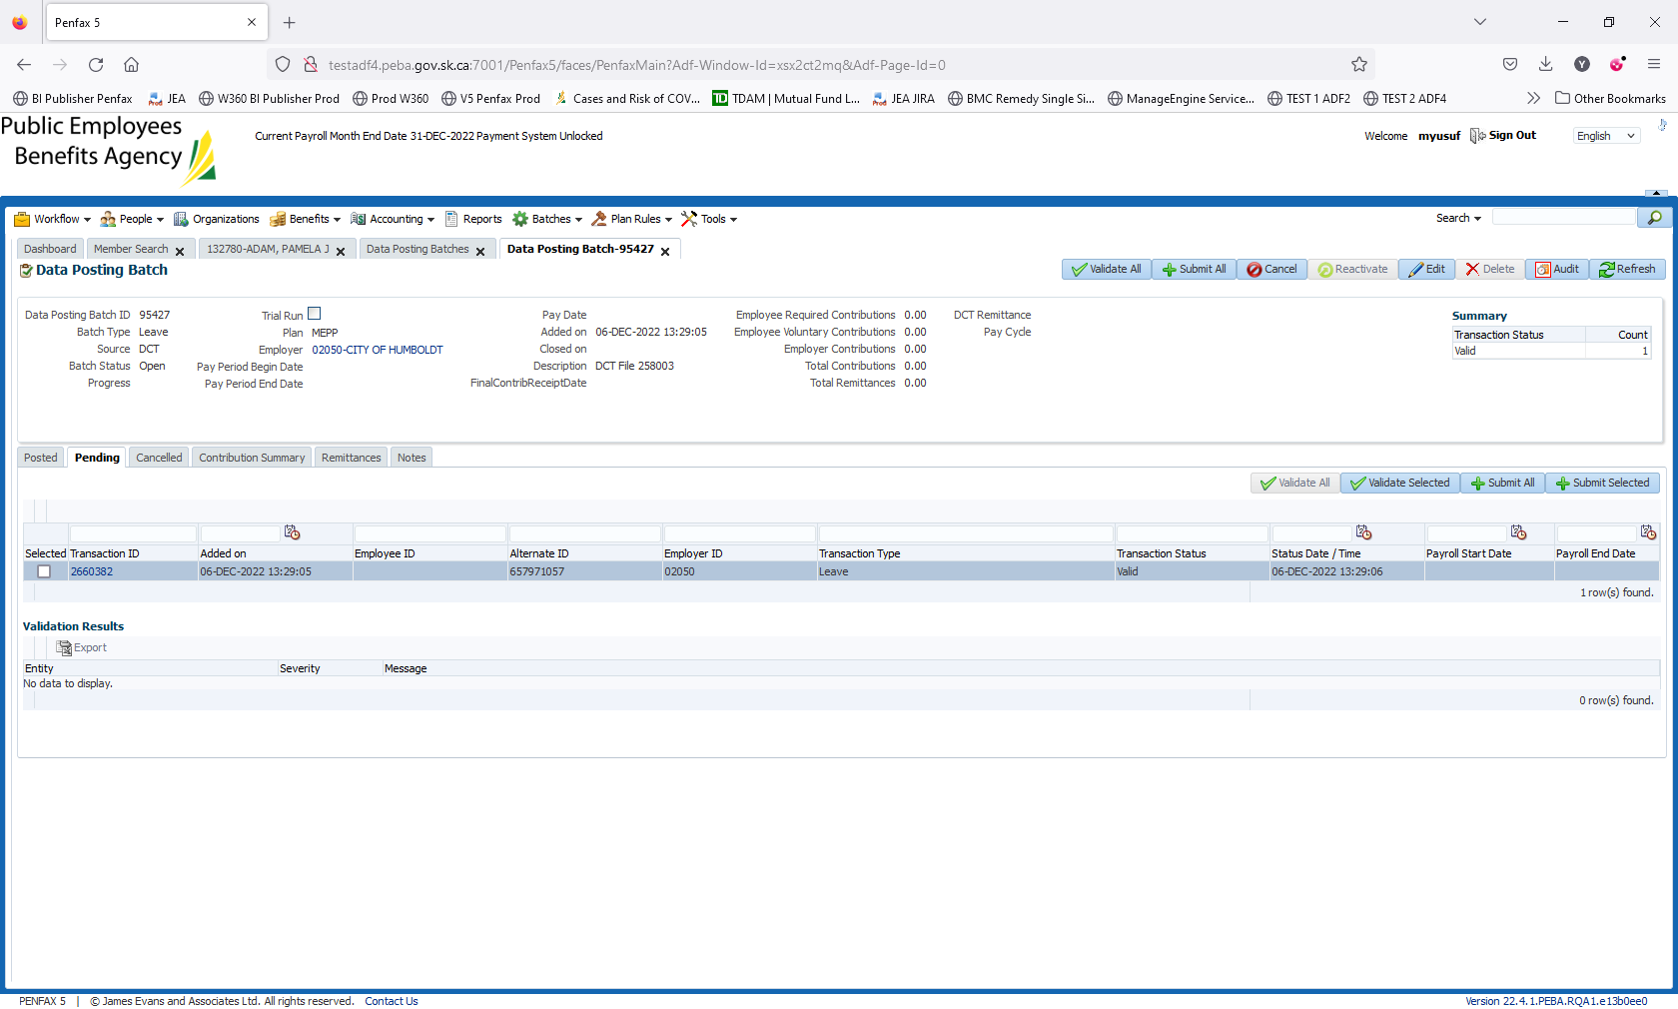

1. Click on Submit All.

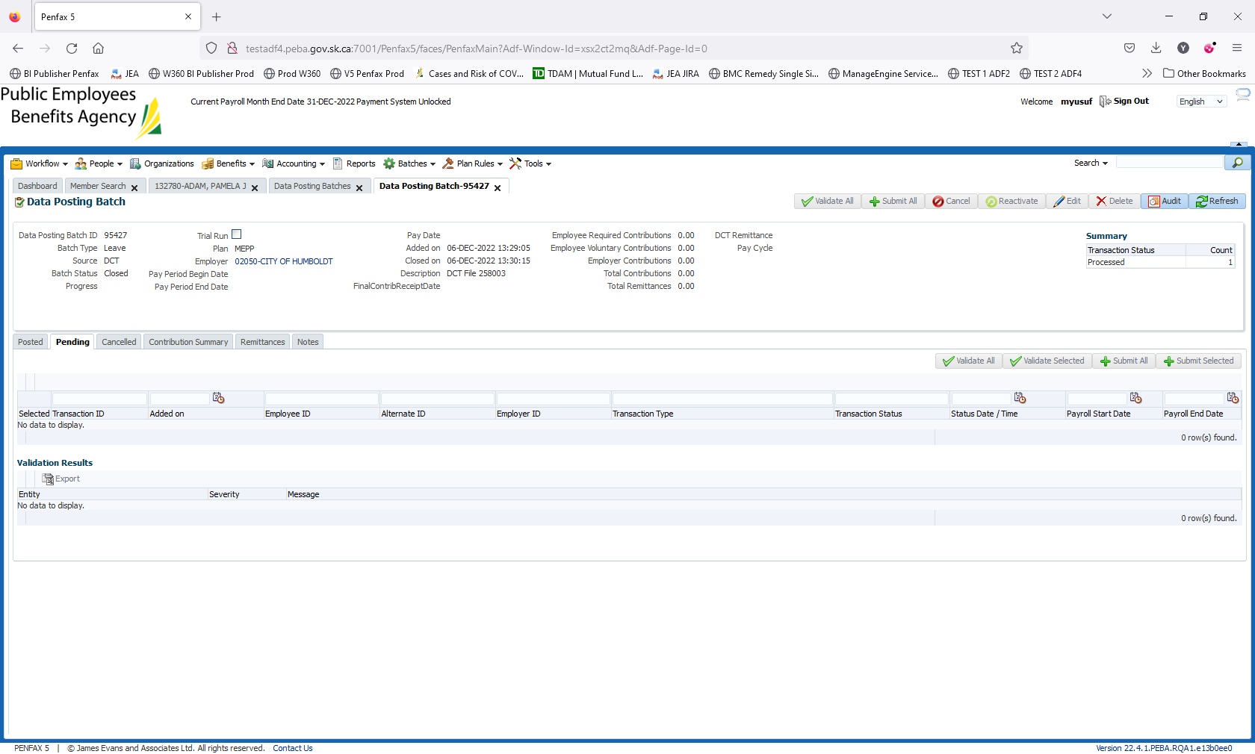

1. Batch is submitted/processed. The transaction is moved to Posted tab. The batch Status is now Closed.

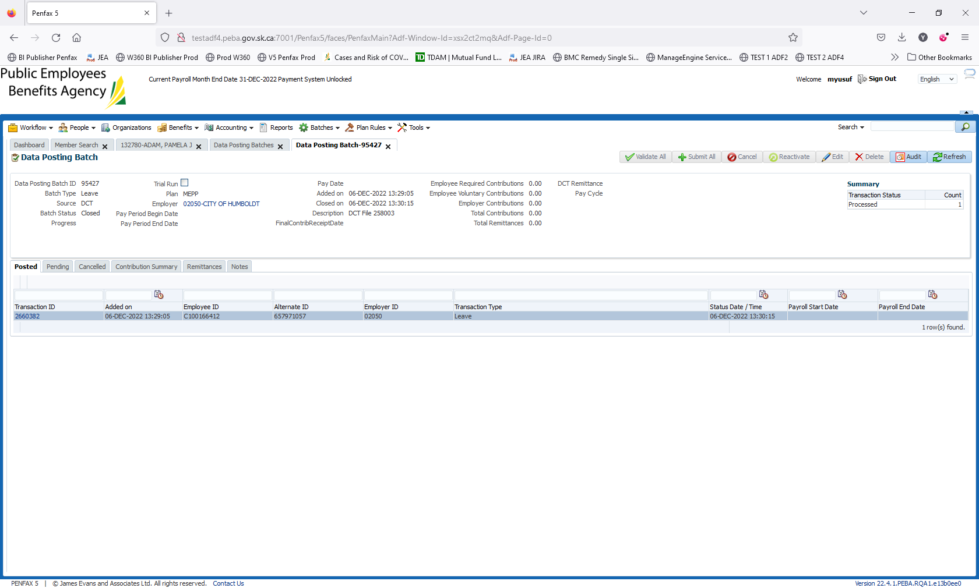

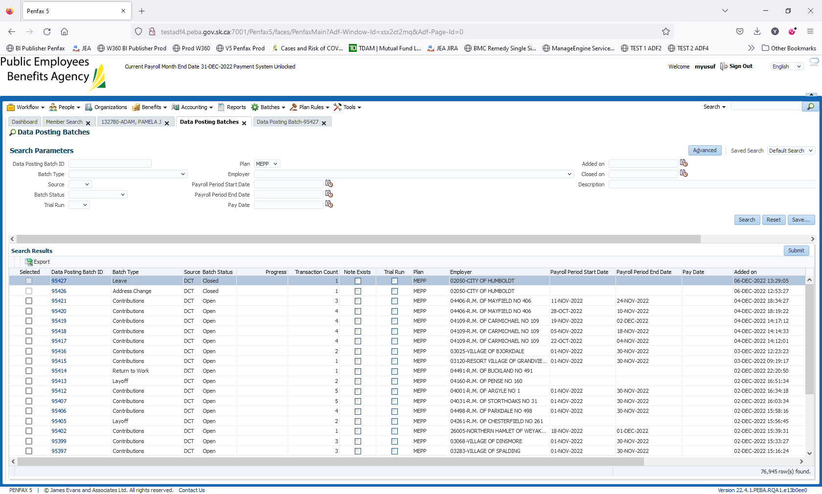

1. Bring up a stakeholder and verify that the leave has been added under Employee Profile -> Leaves.

